MONTHLY TEST – JUNE 2019

Marks obtained:

Total:25
Name: _____________
Grade: _I Section___
Subject: Maths
Date:26.6.19
Time: 1 Hour
I. Write the numbers from 1 to 20. 5

II. Write whether the following is true or false. 5X1=5
1.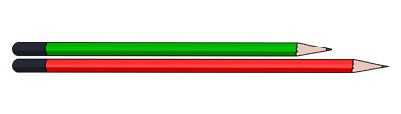The dark pencil is shorter than the light one. __________
2. 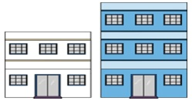The first building is shorter than the second building. __________
3. The boy is shorter than the girl.__________
4. 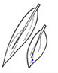 Both the leaves are of equal .__________

5. 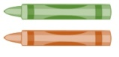Both the crayons are of equal length.__________
III. Match numerals and number names to the corresponding image showing the number of objects. 5x1=5

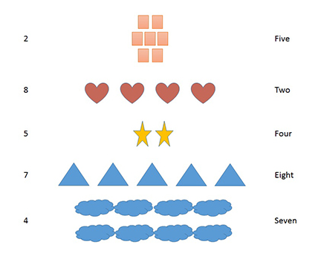
IV. What comes before, after and between? 5x1=5
a) 2 ______
b) 7 ______ 9
c) _______ 3
d) 8 _______
e) 5 _______ 7
V. Arrange the objects shown in the images in order from the shortest to the longest. 5x1=5
Ruler Eraser Pin
Watch Key
Shortest Longest

